Minor Project Synopsis Report
MindSpace
Projexa Team Id - 26E1055

Projexa Team Name- Error_runtime


Submitted in partial fullfilment of the requirement of the degree of
Bachelors of Technology
In
Computer Science and Engineering
To
K. R. Mangalam University
Under the supervision of
Dr. Shahid Ahmad Wani

Department of Computer Science and Engineering
School of Engineering and Technology
K.R Mangalam University, Gurugram- 122001, India
January 2026

1. ABSTRACT
Road traffic accidents represent a major public health challenge, claiming countless lives and causing significant economic loss globally. One of the most significant limitations of modern navigation systems is their focus on optimizing speed and efficiency, often failing to account for the "safety" of a route based on historical accident data.
This project, SafeRoute, aims to bridge this gap by developing a data-driven analytical tool. By leveraging Python for data processing and the K-Means clustering algorithm for spatial analysis, the system will identify "black spots"—geographic coordinates with a disproportionately high frequency of accidents. The final output will be an interactive geospatial heatmap, rendered using Folium, that visualizes risk levels for commuters and city planners. This system transforms raw historical data into visual, actionable intelligence, moving from reactive analysis to proactive safety awareness.
KEYWORDS: Traffic Safety, K-Means Clustering, Geospatial Analysis, Python, Data Visualization.

2. INTRODUCTION
The rapid urbanization of metropolitan cities has led to an exponential increase in vehicular traffic. With this growth comes the inevitable rise in road traffic accidents (RTAs). According to the World Health Organization (WHO), road traffic injuries are a leading cause of death for children and young adults aged 5–29 years.
In many developing nations, accident data exists but often remains locked in static tabular formats—CSV files or police reports—that are inaccessible to the general public. Standard navigation applications like Google Maps or Waze rely heavily on real-time traffic congestion data to route users. However, "fastest" does not always mean "safest." A route might be clear of traffic but may pass through a poorly lit intersection or a sharp turn known for frequent collisions. There is a critical need for a system that transforms raw historical data into visual, actionable intelligence.
By applying rigorous data science techniques to the chaotic domain of road traffic, we aim to uncover hidden patterns that can save lives.

3. MOTIVATION
The primary motivation for this project stems from the urgent need to address the lack of predictive safety awareness for daily commuters. While municipal authorities often react to accidents after they occur, there is a distinct lack of tools that identify high-risk clusters proactively.
Current routing algorithms penalize "time" but do not penalize "risk". This "Navigation Bias" means that users are often unknowingly directed through dangerous intersections simply to save a few minutes. The motivation behind SafeRoute is to democratize access to safety information. By visualizing invisible risks—transforming dry statistical tables into an interactive safety map—we empower citizens to make informed travel decisions. The goal is to shift the paradigm of navigation from "fastest route" to "safest route," potentially saving lives through better awareness.

4. LITERATURE REVIEW
A comprehensive review of existing solutions and research papers was conducted to understand the current state of traffic safety analytics.
CCTV and Vision-Based Systems: Much like the extensive research on CCTV for crime prevention, traffic safety has heavily relied on surveillance. However, research by Srinith et al. (2025) highlighted that while static charts are useful, they fail to convey spatial context effectively to non-technical stakeholders.
Machine Learning in Traffic: Research by Wahyono et al. (2024) demonstrates the efficacy of unsupervised learning in traffic analysis. Their study applied K-Means clustering to traffic data, successfully isolating specific districts as high-risk areas. This validates the choice of K-Means for this project, as it is computationally efficient for distinct geographic grouping.

Table 1: Literature Review Summary
Author | Year | Title | Findings
Wahyono et al. | 2024 | K-Means Clustering for Identifying Traffic Accident Hotspots | Unsupervised learning (K-Means) successfully isolated high-risk districts from raw traffic data, proving clustering is effective for hotspot detection.
Srinith et al. | 2025 | Traffic Pattern Analysis Using GPS Data in Python | Static charts are insufficient for spatial data. Interactive heatmaps (using Folium/Leaflet) are the most effective medium for communicating risk.
Sinanaj & Bexheti | 2023 | Analysis and Visualization of Road Accidents Using Heatmaps | Web-based heatmaps significantly aid decision-making for authorities by visualizing accident severity density.

5. GAP ANALYSIS
From the numerous researches done for traffic management, most existing systems function merely as "Dashboards" for police authorities—showing charts and tables.
Gap 1: Lack of Commuter Perspective Very few solutions focus on the commuter's perspective. Existing data is often locked in government files or used only for post-accident investigation, not for pre-trip planning.
Gap 2: Lack of Risk Quantification There is an absence of a "Severity Score" in many existing maps; they often show all accidents as equal dots, regardless of whether it was a minor scrape or a fatal collision.
Our Contribution:
SafeRoute addresses these gaps by using weighted clustering (accounting for severity) and deploying the result as a browser-accessible map. It bridges the gap between raw government data and the end-user.

6. PROBLEM STATEMENT
The core problem is the lack of predictive safety awareness for daily commuters.
- Data Invisibility: Historical accident data is available on Open Government platforms but is not visualized for the end-user.
- Reactive Infrastructure: Municipal authorities often react to accidents after they occur, rather than identifying high-risk clusters proactively.
- Navigation Bias: Current routing algorithms penalize "time" but do not penalize "risk".
There is a critical need for a system that transforms raw historical data into visual, actionable intelligence.

7. OBJECTIVES
The primary objectives of the SafeRoute project are:
- Data Aggregation: To collect, clean, and preprocess historical accident datasets from open sources (e.g., OGD Platform India, Kaggle) to create a unified data structure.
- Hotspot Identification: To implement the K-Means Clustering algorithm to mathematically group accident coordinates and identify centroids of high-risk zones ("black spots").
- Risk Quantization: To assign a "Severity Score" to each cluster based on the number of casualties and accident frequency.
- Visualization: To develop a web-based interactive interface using Folium that overlays these risk clusters on a real-world map, allowing users to zoom and inspect specific road segments.

8. TOOLS/PLATFORM USED
For this project, we have used various latest technologies which are detailed below.
Programming Language: Python We have used Python language as it is relatively new compared to other languages like Java and comes with extensive support for Data Science. It allows us to perform Machine Learning and geospatial analysis efficiently.
Libraries & Frameworks:
- Pandas: For data cleaning, normalization, and removing null geospatial coordinates.
- Scikit-Learn: For implementing the K-Means Clustering algorithm.
- Folium: A Python wrapper for Leaflet.js used to generate the interactive map and heatmap layers.
- NumPy/Matplotlib: For numerical operations and preliminary plotting.
Hardware Requirements:
- Processor: Intel Core i3 or higher / AMD Ryzen 3.
- RAM: Minimum 4GB (8GB recommended).

9. METHODOLOGY
The project follows the Data Science Lifecycle (DSLC), consisting of data collection, preparation, modeling, and visualization.
9.1 Data Collection & Preprocessing Data is acquired from the Open Government Data (OGD) Platform India. The Python Pandas library is used to remove records with null coordinates and normalize timestamp formats.
9.2 Algorithm: K-Means Clustering To identify "black spots," we use the K-Means Clustering algorithm.
- Why K-Means? It is an unsupervised learning algorithm ideal for finding groups (clusters) in unlabelled data.
- Process: The algorithm selects $K$ random centroids, assigns every accident point to the nearest centroid, and iteratively updates the centroids until they converge .
9.3 Visualization Layer The visualization is built using Folium. It creates a density heatmap representing the overall frequency of accidents and places interactive markers at the calculated centroids of the clusters.

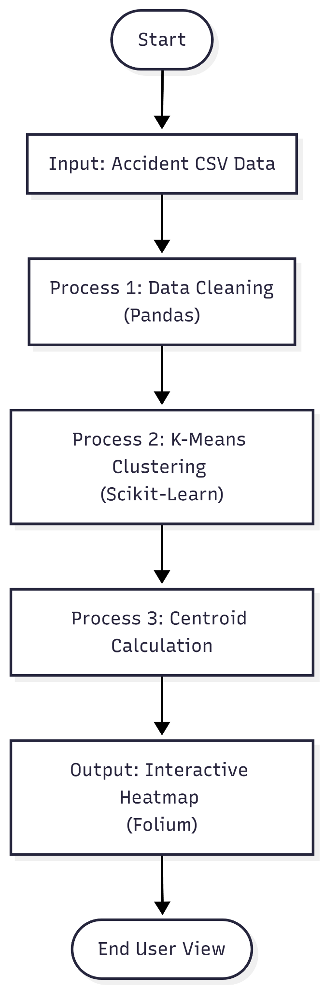
Figure 1: Architectural Diagram

Architectural Flow:
- Input: Raw CSV File (Accident Data)
- Process 1 (Cleaning): Pandas Script cleans null values and formats dates.
- Process 2 (Modeling): Scikit-Learn K-Means model groups coordinates into Clusters.
- Output: Folium generates an HTML Map file with Heatmap layers.

10. REFERENCES
- H. Wahyono, H. Setiaji, T. Hartati, and N. Wiliani, "K-Means Clustering for Identifying Traffic Accident Hotspots in Depok City," Journal of Applied Research In Computer Science and Information Systems, vol. 2, no. 1, pp. 159–170, June 2024.
- D. Srinith, G. S. K. Reddy, and P. R. Krishna, "Traffic Pattern Analysis Using GPS Data in Python," International Journal for Research Trends and Innovation (IJRTI), vol. 10, no. 7, pp. 12–15, July 2025.
- S. Sinanaj and S. Bexheti, "Analysis and Visualization of Road Accidents Using Heatmaps Based on Web Data," SEEU Review, vol. 18, no. 2, 2023.
- Scikit-Learn Developers, "K-Means Clustering Documentation," Scikit-learn.org, 2024.
- Ministry of Road Transport and Highways, "Road Accidents in India 2022," Government of India, New Delhi, 2023.

